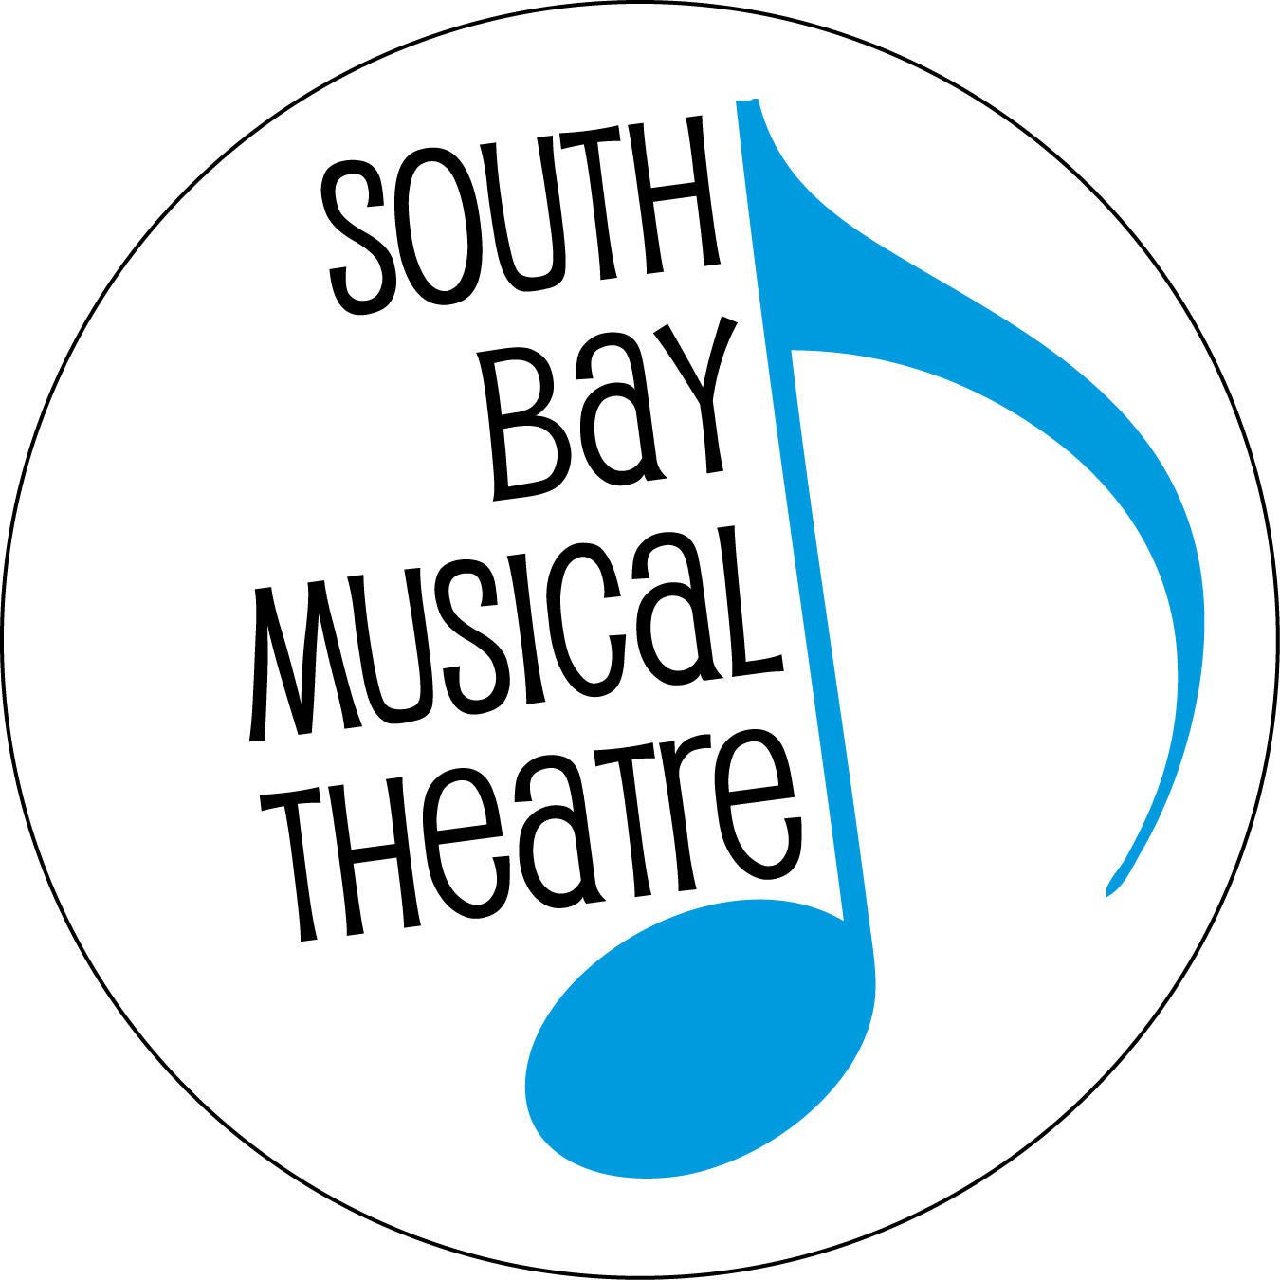

FOR IMMEDIATE RELEASE Contact: Doug Hughes
408-476-2267
doug.hughes@southbaymt.com

SOUTH BAY MUSICAL THEATRE TO PRESENT
“BIG RIVER” JANUARY 26 TO FEBRUARY 16

South Bay Musical Theatre brings another Broadway classic to Silicon Valley with its current production of Big River: The Adventures of Huckleberry Finn. The show runs weekends Jan. 26 to Feb. 16, 2019 at the Saratoga Civic Theater, 13777 Fruitvale Ave., Saratoga. Evening performances start at 8 p.m. while matinees (Sundays and the closing Saturday) start at 2:30 p.m. General admission tickets are $29-$39. There are $2 discounts for seniors 65 years or older, and $20 tickets for students and children. Tickets may be purchased online at www.SouthBayMT.com or by calling (408) 266-4734.

“Big River is the story of Mark Twain’s Huckleberry Finn,” says Doug Brook, who directs this innovative production for SBMT. “While there’s great music and humor, it’s the story that makes it all matter. Huck’s is a great tale of youthful exuberance and starting to grow up in the world. Jim’s story is about a quest for freedom. Together, they take us on their journey—traveling together, as one, toward their respective dreams.”

The show took Broadway by storm in 1985, sweeping both the Tony and Drama Desk Awards with ten Tony nominations (and seven wins), and 14 Drama Desk nominations (and nine wins). Notable awards included Tonys for Best Musical, Best Book, and Best Score. In a period dominated by British imports, this was a uniquely American story, and it ran for more than 1,000 performances, featuring catchy bluegrass and country music by “King of the Road” composer Roger Miller.

More than three decades later, the story holds up well, and its commentary on racism and religion, greed and gullibility, and mob mentality vs. independent thinking are newly relevant in today’s divisive political environment.

“To me,” Doug Brook continues, “the play is about unity. Twain wrote a satire pointing out the flaws in society, in an older time when we all acknowledge there were flaws aplenty. Through the eyes of a newer generation (Huck) in that older time, we can see how far we’ve come, but also how far we still have to go. Big River brings us Twain’s wit, Huck’s boyish adventurism, Jim’s quest for freedom, and an ensemble full of rich characters. The score is a terrific mix of music genres, all written by Roger Miller. There’s meaning in the play on several levels for people to find, but it’s also a very fun escape for people who want simply that.’’

The story
The musical transports us back in time to Missouri in the 1840s, when slavery still plagues America. Huckleberry Finn, who was a supporting character in Twain’s earlier novel, Tom Sawyer, is the lead character here, and we join him as a teenager growing up in the small town of St. Petersburg. When his life is threatened, Huck escapes on a raft down the Mississippi River, where he meets up with a runaway slave named Jim, who is trying to find his wife and children up North. As they set off on their journey, they get sucked into scams involving a couple of conmen, a pretty girl, and a variety of comic characters, providing both outrageous humor and heart-breaking pathos.

SBMT’s production features a cast of 30 actors with dozens of staff and volunteers working behind the scenes. Ben Hatch stars as Huck Finn and Anthone Jackson plays Jim.
South Bay Musical Theatre, formerly known as the Saratoga Drama Group, has been presenting award-winning productions for 56 years, since its establishment in 1963. This is the first time the company has staged Big River. For more information or to obtain tickets online, visit their website at www.SouthBayMT.com.

###

