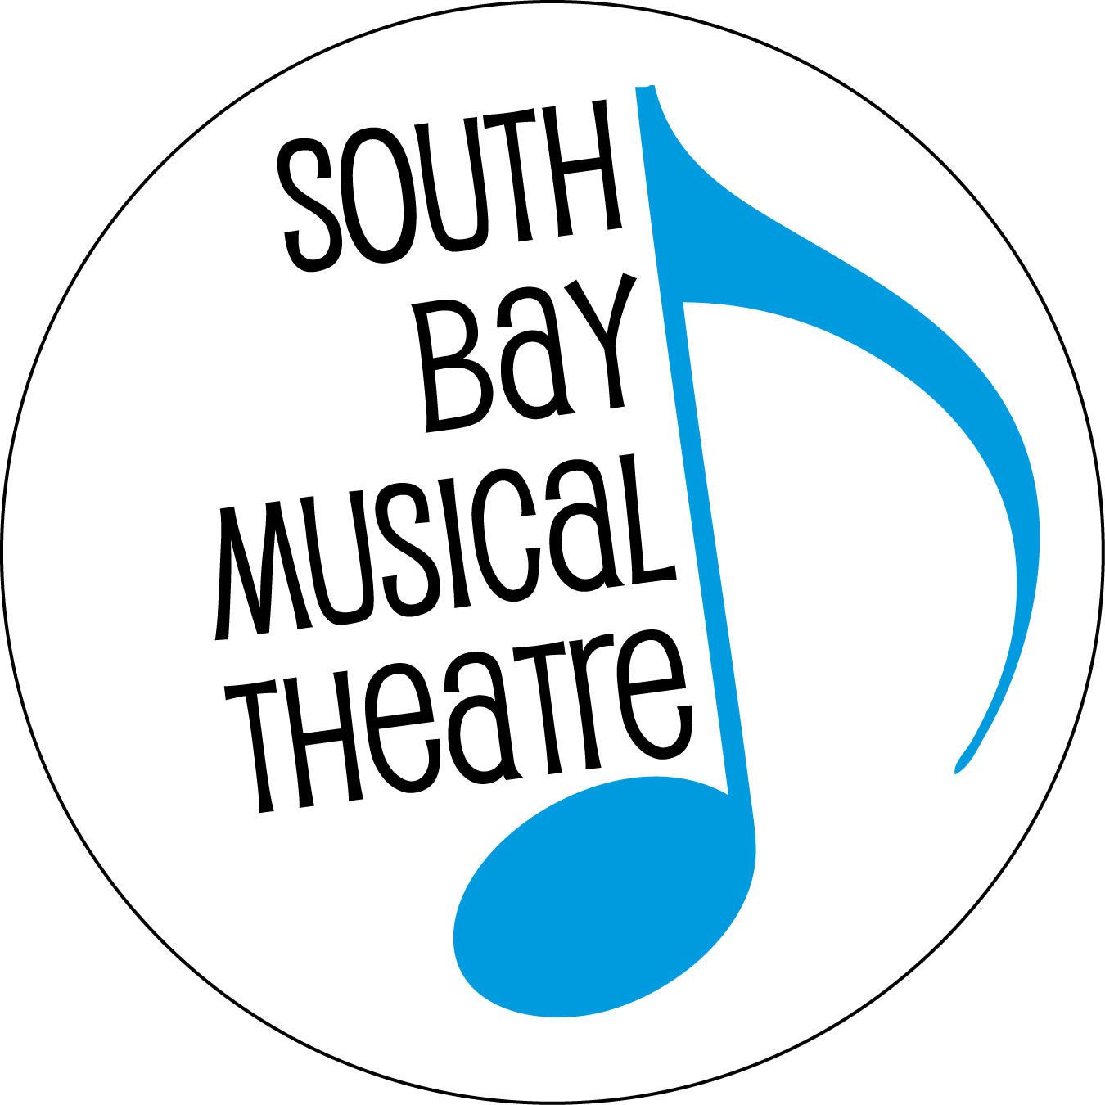

FOR IMMEDIATE RELEASE Contact: Doug Hughes
408-476-2267
doug.hughes@southbaymt.com

“THOROUGHLY MODERN MILLIE” TO OPEN MAY 18TH
SOUTH BAY MUSICAL THEATRE TO PRESENT THE TOE-TAPPING, TONY WINNING SHOW

South Bay Musical Theatre plans to close its successful 2018-2019 season by bringing Thoroughly Modern Millie to eager South Bay audiences. Described as a “high-spirited musical romp” that is a “delightful valentine to the long-standing spirit of New York City and the people who seek to discover themselves there,” the musical comedy is a favorite of tap lovers everywhere. With seasoned director/choreographer and SBMT favorite Lee Ann Payne at the helm, the show will feature a cast of 22 talented Bay Area triple threats and stars Jessica Maxey as Millie Dillmount. The role was first made famous by Julie Andrews in the 1967 film, and later propelled Sutton Foster from one-time understudy to both Broadway stardom and her first Tony award.

The winner of six Tony Awards — including Best Musical — Thoroughly Modern Millie was the 2002 season’s most awarded new show on Broadway. The score includes notable favorites like “Forget About the Boy”; “I Turned the Corner”; “Gimme, Gimme”; and, of course, the toe-tapping title tune. Thoroughly Modern Millie features a book by Richard Morris and Dick Scanlan, new music by Jeanine Tesori, new lyrics by Dick Scanlan, and an original story and screenplay by Richard Morris for the Universal Pictures film.

“Thoroughly Modern Millie is really a love letter to the awe of New York City and the dreams that people have of finding themselves,” says Lee Ann Payne, who directs and choreographs this high-energy production for SBMT. “Millie is indefatigable, and we are so fortunate to have Jessica Maxey fill this role — she is a true performer in every sense of the word. And, this cast! The characters around Millie are as diverse and vibrant as the city itself, and each and every one of them is a triple threat. From tap to ballet to jazz to ballroom — this cast can execute it all.”

The show runs weekends May 18 to June 8, 2019 at the Saratoga Civic Theater, 13777 Fruitvale Ave., Saratoga. Opening night patrons will enjoy a champagne toast with the cast following the first performance. Evening performances start at 8 p.m. while matinees (Sundays and the closing Saturday) start at 2:30 p.m. General admission tickets are $29-$39. There are $2 discounts for seniors 65 years or older, and $20 tickets for students and children. Tickets may be purchased online at www.SouthBayMT.com or by calling (408) 266-4734.

The Artistic Team
Director & Choreographer: Lee Ann Payne
Assistant Director & Choreographer: Jennifer C. Maggio
Musical Director: Joseph Kelly
Vocal Director: Kevin Brownstein
Assistant Vocal Director: Michael Stahl
Executive Director: Sara K. Dean

The Cast
MILLIE: Jessica Maxey
JIMMY: James Jones
DOROTHY: Felicia Chang
TREVOR: Michael Rhone
MUZZY: Gwyneth Price Panos
MRS. MEERS: Karyn Rondeau
MISS FLANNERTY: Mylissa Malley
CHING HO: Justin Fan
BUN FOO: Edmond Kwong
ETHEL/ENSEMBLE: Francesca Cipponeri
FEMALE ENSEMBLE:
Lindsey Duran, Gwyneth Forrester, Rhona McFadyen, Bethany Mindrum, Amanda Nguyen, Sarah Rosenberg, Elizabeth Geurts (Female Swing)
MALE ENSEMBLE:
Steve Allhoff, Kyle Arrouzet, Christopher Pynchon, Michael Saenz, Braden Taylor

The Story
Based on the 1967 Academy Award-winning film, Thoroughly Modern Millie takes you back to the height of the 1920s Jazz Age in New York City, when “moderns,” including a flapper named Millie Dillmount, were bobbing their hair, raising their hemlines, entering the workforce, and rewriting the rules of love. Millie has carefully calculated romantic plans to find the perfect, successful husband, but an unexpected meeting with penniless Jimmy Smith might just change all that. Filled with dancing flappers, dashing leading men, and a dragon lady of a villainess that you’ll love to hate, “Thoroughly Modern Millie” is perfectly constructed madcap merriment.

South Bay Musical Theatre, formerly known as the Saratoga Drama Group, has been presenting award-winning productions for 56 years, since its establishment in 1963. For more information or to obtain tickets online, visit their website at www.SouthBayMT.com.

###

