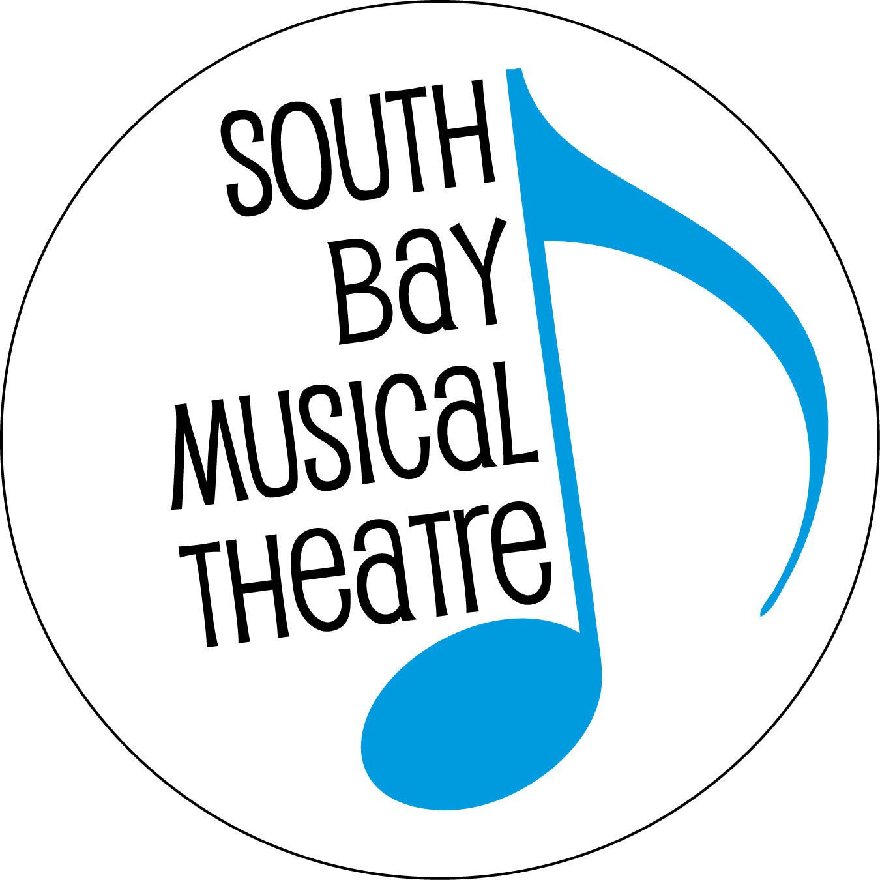

Noteworthy Entertainment

FOR IMMEDIATE RELEASE Contact: Doug Hughes
408-476-2267
doug.hughes@southbaymt.com

“A GENTLEMAN’S GUIDE TO LOVE AND MURDER” TO OPEN SEPTEMBER 28
SOUTH BAY MUSICAL THEATRE TO PRESENT THE BAY AREA’S FIRST COMMUNITY THEATRE PRODUCTION OF THE TONY-AWARD-WINNING MUSICAL COMEDY

South Bay Musical Theatre (SBMT) is pulling out all the stops to bring the show USA TODAY called “morbidly hilarious” — A Gentlemen’s Guide to Love and Murder — to eager Bay Area audiences. Featuring a likeable leading man murdering his way up the social ladder in Edwardian England, the show was highly praised for its ingenuity. It was the winner of four Tony Awards in June 2014 — including Best Musical, Best Book of a Musical, Best Direction, and Best Costume Design. Director Walter M. Mayes will introduce a new look for this local production, inspired by the gothic pen and ink artwork of American artist Edward Gorey.

A Gentlemen’s Guide to Love and Murder features a gorgeous, classically-styled score by Steven Lutvak, and lyrics and book by Robert L. Friedman. It is a show that demands both stellar, classically-trained voices and ridiculous comedic chops to keep the audience simultaneously charmed and somewhat repulsed. The production stars local favorites David Mister as the penniless Monty Navarro, who learns that he’s eighth in line for a fortune and devises an outlandish plan to knock off the nasty aristocrats standing in his way, and Michael Hirsch as the entire D’Ysquith Family (eight unique members – both male and female!) It also features a show-stopping number (“I’ve Decided to Marry You”) full of slamming doors, performed by the love triangle of Mister as Navarro, plus Jillian Bader as Sibella Hallward and Kate Matheson as Phoebe D’Ysquith. While the Broadway tour of A Gentlemen’s Guide to Love and Murder came through San Francisco a few years ago and the show was mounted recently by a local children’s troupe, this will be the first community theater production to open in the entire San Francisco Bay Area.

Although the show is a modern musical, director Mayes and the rest of his artistic staff are leaning into the dark, unsettling, yet tongue-in-cheek nature of the story and Edwardian setting, and basing the production’s visual look on the work of Gorey. “The work of Edward Gorey is immediately recognizable to audiences, even if he’s not quite a household name,” notes Mayes. “Any viewer of the PBS Series Mystery! will recognize the ravens and tombstones of the animated opening credits, setting the mood that what you are about to see will be a bit dark, but also witty and engaging. Black and white dominates the set and the look of the show, echoing Gorey’s pen and ink lines.” Gorey (1925-2000), is best known for his illustrated books such as The Gashlycrumb Tinies and Old Possum’s Book of Practical Cats. The latter features T.S Eliot’s poetry and Gorey’s illustration, and is the source material of the musical Cats! Gorey is also a Tony-award winner himself, designing the costumes for the 1977 Broadway revival of Dracula.

The show runs weekends Sept 28 to Oct. 19, 2019 at the Saratoga Civic Theater, 13777 Fruitvale Ave., Saratoga. First-nighters are invited to stay for a champagne toast following the opening night performance. Evening shows start at 8 p.m. while matinees (Sundays and the closing Saturday) start at 2:30 p.m. General admission tickets are $29-$39. There are $2 discounts for seniors 65 years or older, and $20 tickets for students and children. Tickets may be purchased online at www.SouthBayMT.com or by calling (408) 266-4734.

The Artistic Team
Director: Walter M. Mayes
Musical Director: Dan Singletary
Vocal Director: Anita Carey
Choreographer/Assistant Director: Jennifer Maggio
Costume Design: Michael Johnson, Mae Matos, Lisa Rozman
Hair & Makeup Design: Gwyneth Price Panos
Lighting Design: Edward Hunter
Props Design: Patricia Bilello
Set Design: Heather Kenyon
Sound Design: Chris Beer
Stage Manager: Ben Hemmen

SBMT Executive Director: Sara K. Dean

The Cast
MONTY: David Mister
THE D’YSQUITH Family: Michael Hirsch
SIBELLA: Jillian Bader
PHOEBE: Kate Matheson
MISS SHINGLE: Ruth E. Stein
THE PLAYERS: Brett Carlson, Andrew Cope, Michael Cuddy, Brennah Kemmerly, Jennifer Noel Medeiros, Dana Cordelia Morgan, Alea Selburn, Michael Stahl, Brianna Stutzman and Braden Taylor.

The Story
After discovering he is eighth in line for a fortune, young Monty Navarro devises an outlandish plan to knock off the nasty aristocrats standing in the way of claiming his title as the Earl of Highhurst. Along the way, he becomes torn between two beautiful women – Sibella, his “first love” who rejected him as a suitable candidate in marriage due to his modest means and social status, and Phoebe, a young and noble member of his aristocratic family, whom he admires and respects. Will he get away with murder long enough to claim his inheritance? And if he does, will it be Sibella or Phoebe at his side in the end?
South Bay Musical Theatre, formerly known as the Saratoga Drama Group, was founded in 1963 and is now in its 57th year of entertaining Bay Area audiences as a non-profit organization. For more information or to obtain tickets online, visit their website at www.SouthBayMT.com.

###
QUESTIONS & ANSWERS
AN INTERVIEW WITH WALTER M. MAYES, DIRECTOR OF
A GENTLEMAN’S GUIDE TO LOVE & MURDER

How do you describe this musical to your friends and family?
A man finds out that he is eighth in line for a title in England in the 1910s and accidentally stumbles into a plot where he figures out how to remove all of the obstacles in his path, all the while entertaining two different women who could become his wife. And hilarity ensues.

What about the show has you the most excited?
What has me most excited? Well, let’s start off with the fact that it’s one of the few musicals that is written with two leads for legit sopranos, so I have access to extraordinary talent in this show. Every single one of my cast is a beautiful, beautiful singer. My leads are just astonishing, and they can act, too.

What do you love about this musical?
There’s so much about the show that I love. I love the opportunity to tell a succinct story in a theatrically wild style. It has a very, very clear goal of letting the audience follow the trajectory and identify with this young, hapless man, who takes on the task of revenging his mother who has been ostracized by her family. I like the fact that it has lots of wonderful bits and comedy bits and romantic bits and precision bits for the “players” (as we’re calling our ensemble), and I believe, at last count, 97 costumes.

How was this production different from the Broadway production?
Well, Broadway had a lot more money to spend on the show than we did and we have to be creative with our choices. There are certain aspects of the show that are design elements that are dictated by the script, so we do have to follow how certain things are done—the way they were done on Broadway. But we are also putting our own style onto the show. Our design elements are reflecting an illustrator that I’m very fond of named Edward Gorey whose Edwardian line drawings lend themselves beautifully to this particular expression. And our ensemble: instead of an ensemble of six as they had on Broadway, we have an ensemble of 10, which allows us to spread the parts around a few more players.

Who was Edward Gorey, and what about his work inspired you?
Edward Gorey was very eccentric illustrator and writer who was known for his very detailed, black-and-white line illustrations that were done in pen and ink that always featured people in Edwardian clothing and always featured slightly macabre tellings and absurdist situations. The marriage of Gorey-inspired design and the story that this story is trying to tell sets the perfect tone for a lighthearted Edwardian murder mystery romp.

What type of show is A Gentleman’s Guide to Love & Murder?
This is one of those shows that pulls its inspiration from a variety of places. It’s very much British music hall. It’s got influences of grand opera and operetta. There is more than a touch of Gilbert & Sullivan in here, and then traditional musical comedy tropes throughout. One of the things that’s very interesting about this show musically is it features a lot of waltzes. I mean, I think there are, like, six or seven of them in the show, and that’s unusual for musical theatre. The other thing about it is that it requires legit voices in the principals, and that is not something that you run into in a lot of musical theatre. I tell everybody with the women’s parts, that there is no belting at all.

What other shows would you compare this to?
Imagine that Charles Dickens and Edgar Allen Poe collaborated on a novel together. Then Gilbert & Sullivan decided that they were going to turn it into an operetta, and then Oscar Wilde got ahold of the script and touched it up with little flairs of his own. It’s definitely set in the same era as the earlier Downton Abbey episodes. Definitely if you like The Mystery of Edwin Drood, and the music hall feeling of this, there is a certain element of that in this show. And then, I also think of any of the great British comedies of, I believe the studio was called Ealing. They made wonderful black and white comedies, many of which starred people like Peter Sellers, and Alec Guinness, and if you like that kind of British humor, not quite into the world of Monty Python, but everything that Monty Python is based on, you’re going to love this kind of musical.

A show about murder? Is this another Sweeney Todd?
Oh. Well, no. Sweeney makes no pretense about being funny, and A Gentleman‘s Guide To Love And Murder is a very funny show. It is about a man who stumbles into murder, not a man who sets out to get revenge on the world by slashing all their throats. It’s based on an old British comic movie called Kind Hearts And Coronets, and it featured Alec Guinness as every member of this family that gets murdered and it’s a comic tour-de-force performance, so when they created the musical they kept the same device of one actor playing all nine roles.

Why was SBMT so eager to do this show?
If you look at SBMT’s history, we have, when possible, leapt on the chance to be the first company in the South Bay or even in the Bay Area to produce a successful Broadway show. This show won the Tony in 2014, and this will be the first Bay Area production of it by an amateur group. We are very excited to do that. We think with the small cast and the brilliant production values, and the glorious score, and the orchestrations, we think this is a show that our patrons will love, but it will also bring in new patrons who love new theatre to come into our theater and watch what we can do.

What advice would you give to those who don't have tickets yet?
As soon as you can see that you can buy a ticket to A Gentleman’s Guide To Love And Murder, you want to grab all of your friends, go and have a nice dinner and a glass of wine, and come to the Saratoga Civic Theater, and watch us put on a show that will delight and astound you with beautiful voices, wonderful acting, and stunning production values: a beautiful set, and gorgeous costumes, and a fabulous orchestra. I hope to see you there.

###

