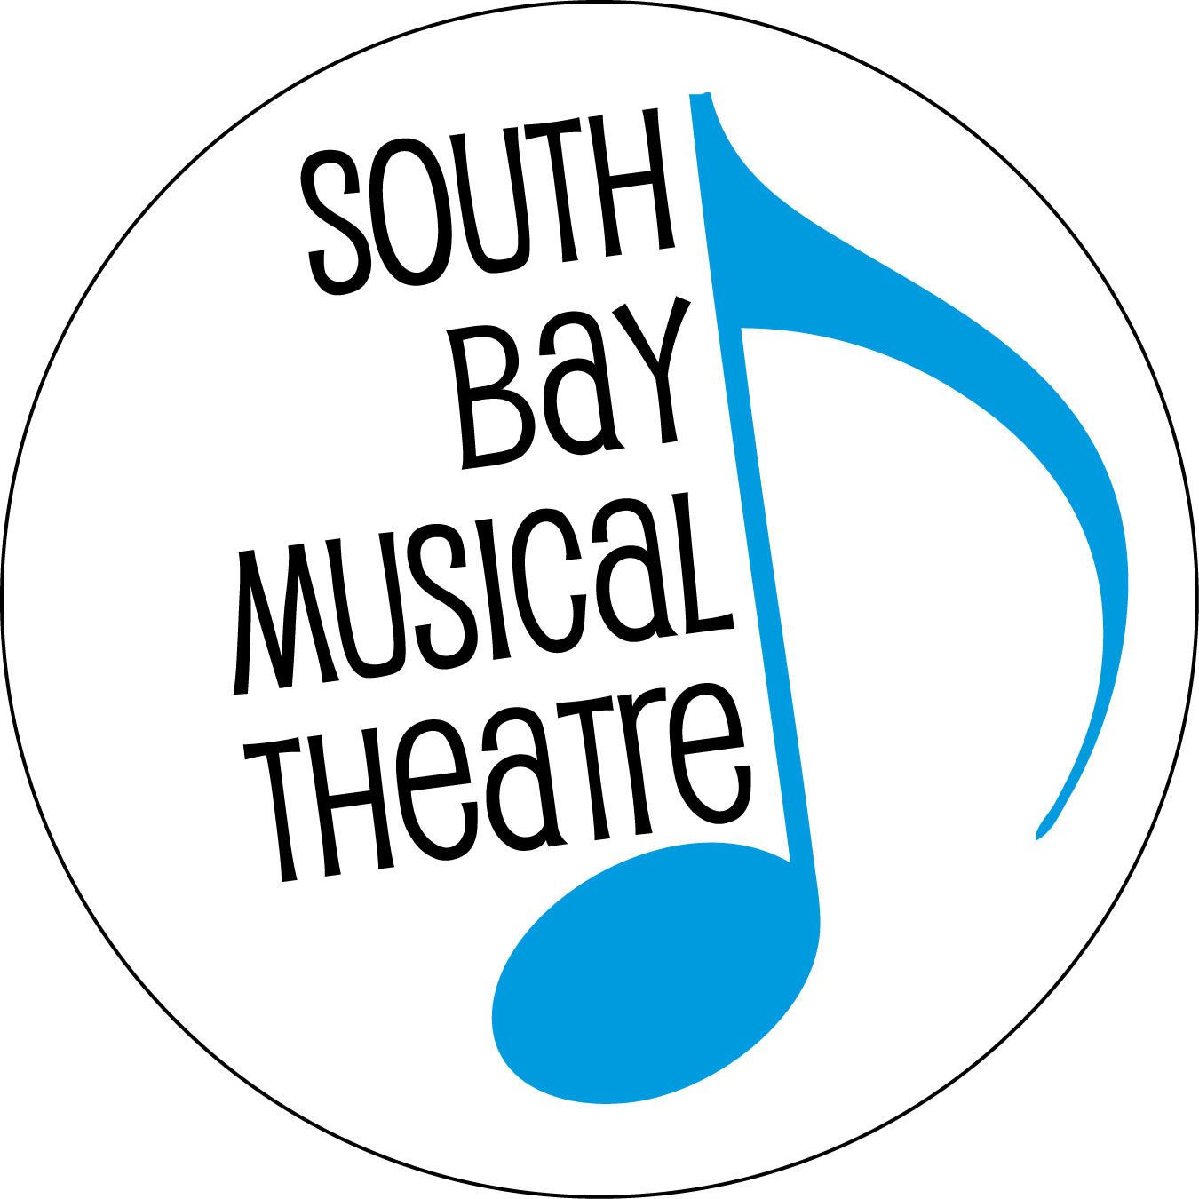

FOR IMMEDIATE RELEASE Contact: Jonathan White
530-219-9797
jonathanwhitepr@gmail.com

SOUTH BAY MUSICAL THEATRE ANNOUNCES
FULL CAST AND CREATIVE TEAM FOR
SHE LOVES ME
JANUARY 25 – FEBRUARY 15, 2020

(December 5, 2019 – Saratoga, CA) South Bay Musical Theatre (SBMT) is pleased the announce the full cast and creative team for the Company’s first 2020 production, the charming musical comedy SHE LOVES ME. Described by The New York Times as “a bonbon of a musical” and a “tasty tale of love lost and found at the workplace,” the original Broadway production of SHE LOVES ME was nominated for five 1964 Tony Awards; the show has since enjoyed two successful Broadway revivals, in 1993 (Winner, Tony Award “Best Revival of a Musical”) and 2016. SHE LOVES ME features a book by Joe Masteroff, music by Jerry Bock and lyrics by Sheldon Harnick. It is based on the play Parfumerie by Miklós László (which has also served as the basis for the films The Shop Around the Corner, In the Good Old Summertime and You've Got Mail).
SBMT’s production of SHE LOVES ME will be directed by Martín Rojas Dietrich, with music direction by Joseph Kelly, vocal direction by Daniel Hughes and choreography by Jillian Toby-Cummings. SHE LOVES ME will perform from January 25 – February 15, 2020 at Saratoga Civic Theatre (13777 Fruitvale Ave, Saratoga, CA 95070), with a press opening on Saturday, January 25, 2019 at 8:00 p.m. First-nighters are invited to stay for a champagne toast following the opening night performance. Evening shows start at 8 p.m. while matinees (Sundays and the closing Saturday) start at 2:30 p.m. Adult tickets are $29 - $39. There are $2 discounts for seniors 65 years or older, and $20 tickets for students and children. Tickets may be purchased online at www.SouthBayMT.com or by calling (408) 266-4734.

"SHE LOVES ME is widely considered to be a perfect musical," says SBMT Executive Director Sara K. Dean. "It's a charming, romantic comedy the whole family will enjoy—a tale of love triumphing over animosity. We are blessed with a stellar cast and a highly talented production staff who are turning this timeless tale into a singing-and-dancing love letter to the South Bay community that rises to the level of quality our audiences have come to expect."
A warm romantic comedy with a touch of old-world elegance (from the bookwriter of Cabaret and the songwriters of Fiddler on the Roof), SHE LOVES ME is set in a
1930s European perfumery. We meet feuding shop clerks Amalia and Georg, each
Page 2 / SBMT presents SHE LOVES ME
of whom responds anonymously to each other’s want ad. The score includes songs like “Dear Friend”; “Vanilla Ice Cream”; “A Trip to the Library”; and, of course, the heart-warming title tune. What better way to celebrate Valentine’s season with your sweetheart than with this Broadway favorite?
The principal cast of SHE LOVES ME includes Ben Hatch as “Georg Nowack,” Marie Finch as “Amalia Balash,” Michael Johnson as “Zoltan Maraczek,” Carlos Nunez as “Steven Kodaly,” Jessica Whittemore as “Ilona Ritter,” Parker Hough as “Arpad Laszlo,” Steve Sammonds as “Ladislav Sipos,” Joseph Cloward as “Kelly/Ensemble” and Don Nguyen as “Maitre'd/Ensemble.” The Ensemble of SHE LOVES ME also includes Miranda Ashton, Christina Bolognini, Dallas Carter, Ethan Glasman, Barbara Heninger, Melissa Jones, Scott Knaster, Cordelia Larsen, and Clara Walker.

In addition to Mr. Dietrich, Mr. Kelly, Mr. Hughes, Ms. Toby-Cummings and Ms. Dean, the creative team for SHE LOVES ME includes Y. Sharon Peng (Costume Designer), Gwyneth Price Panos (Hair and Make-Up Designer), Richard Cartwright (Master Carpenter), Miranda Whipple (Props Designer), Brett Carlson (Set Designer), Dan Singletary (Sound Designer), Alexandra Maisonneuve-Teixeira (Stage Manager), Chris Beer (Technical Director) and Patti Reed (Associate Production Manager).

SBMT’s 2019-2020 season will conclude with Rodgers and Hammerstein’s SOUTH PACIFIC (May 16 - June 6, 2020). The 2020-2021 season will be announced in early 2020. More information is available at www.SouthBayMT.com

About South Bay Musical Theatre
South Bay Musical Theatre, formerly known as the Saratoga Drama Group, was founded in 1963 and is now in its 57th year of entertaining Bay Area audiences as a non-profit organization. For more information or to obtain tickets online, visit their website at www.SouthBayMT.com.
FOR CALENDAR EDITORS:
WHAT: South Bay Musical Theatre presents SHE LOVES ME

WHEN: Jan. 25 – Feb. 15, 2020 (press opening on Sat., January 25, 8:00 p.m.).

Fridays and Saturdays (and Thursday, February 13) at 8:00 p.m.; Sundays (and Saturday, February 15) at 2:30 p.m.
WHERE: Saratoga Civic Theater, 13777 Fruitvale Ave., Saratoga, CA 95070

RUNNING TIME: SHE LOVES ME runs two hours and twenty minutes, including a fifteen-minute intermission.

TICKETS: $20 - $39 and may be purchased online at www.SouthBayMT.com or by calling (408) 266-4734.
###

